60 CHANCES TO WIN
ONLY 500 TICKETS SOLD
Match Florida Evening Pick 3 Straight
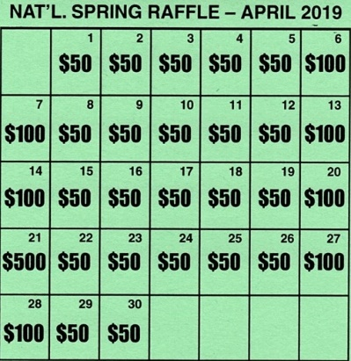
ONE WINNER EACH DAY – TICKET MAY WIN MULTIPLE TIMES
PROCEEDS BENEFIT COMMANDER BARBER’S PROJECT
MISSION: VETERANS MOBILITY
DONATION $10.00
PRIZES AWARDED WEEKLY 04/01, 04/08, 04/22, 04.29. 05/01

“SONS SERVING VETERANS”

