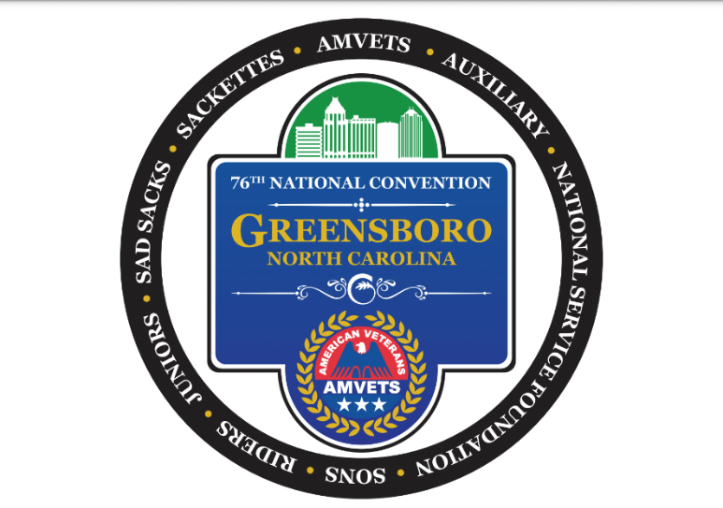

AMVETS National Convention pre-sale tickets for the Silver Helmet Awards Reception, and the Commander and President's Banquet. NOTE: THERE WILL BE NO ONSITE SALES FOR THE SILVER HELMET AWARDS RECEPTION OR THE COMMANDER AND PRESIDENT'S BANQUET. NO EXCEPTIONS
Name:

Address:
City: | State: | Zip:
Cell Phone: | Email:
Department: | Post/Auxiliary/Squadron #:
Silver Helmet Award Tickets: ($20 each) _____________ # of tickets

Coffee, dessert and cash bar. Business or Cocktail Attire.
Commander and President’s Banquet: ($60 each) _____________ # of tickets

Dinner Options: _____ Steak and Chicken ______Vegetarian
Attire is formal.
Name of person picking up the tickets:
TOTAL AMOUNT DUE:_______________________

To purchase tickets by mail, please send completed form and check or money order made payable to AMVETS National Headquarters and mail to AMVETS National Headquarters, Accounting Department, 4647 Forbes Boulevard, Lanham, Maryland 20706. Earmark envelope “Convention Tickets”. Requests for ALL tickets must be RECEIVED at National Headquarters by August 3, 2021.

